**Adaptation and Behavior**

**Lesson #4:** **Wings – Natural Systems and Mechanical Systems**

**Time Frame:** 60 minutes

**Learning Standards:**

*Science*

Life Science: Plant (and Animal) Structures and Functions

1. Give examples of how inherited characteristics may change over time as adaptations to changes in the environment that enable organisms to survive, e.g., shape of beak or feet, placement of eyes on head, length of neck, shape of teeth, color.

*Technology/Engineering*

1. Compare natural systems with mechanical systems that are designed to serve similar purposes, e.g., a bird’s wings as compared to an airplane’s wings.

*English / Language Arts*

Nonfiction

1. 13.13 Identify and use knowledge of common textual features.
2. 13.14 Identify and use knowledge of common graphic features.

**Student will be able to:**

1. Read and discuss an article on bird and airplane wings to explain how engineers use knowledge of animal characteristics to design mechanical devices.
2. Observe, conduct, describe, and explain air pressure demonstrations that relate to flight.
3. Explain how bird wings are adapted to flight.

**Resources and Materials:**

|  |  |
| --- | --- |
| **Item** | **Amount** |
| Science notebooks |  |
| Teacher description of demonstrations and experiments | 1 (in binder) |
| Article: The Physics of Flight | 25 (in bin) |
| Ping pong ball | 2 (in bin) |
| Funnel | 1 (in bin) |
| Strips of paper | 30 (in bin) |
| Spoon | 1 (in bin) |
| Running water | (in classroom) |

**Teacher Background Information:** Pressure is how much the air is pushing on objects that it surrounds. Air pressure on an object is normally the same on all sides so the object can't feel the air. For example, when we stand in a room we know we are surrounded by air. Unless the air moves we won't feel it. However, when air begins to move its air pressure goes down. **Bernoulli’s Principle** states that the faster the air flows the lower the pressure goes. If air is moving on one side of an object the air pressure is lower on that side only. This difference in air pressure will cause the object to move because the air is pushing harder on one side than the other. This is one of the basic ideas behind flight. Flight is also possible because of the **Coanda** effect. Basically, a stream of liquid or gas will stay attached to a curved surface, rather than continue in a straight line. Wings direct air down. Then, this air meets with pressure from the air below it, creating lift.

**Focus Activity:** Ask the students to answer the following question in their science notebooks. How is a bird like an airplane? Make a list of similarities and a list of differences. Students may work individually or in small groups to complete this task. Discuss as a class after students have time to work.

**Introduction:** Introduce the process of design (if necessary). Scientists and engineers identify a problem, research solutions, choose a solution, construct a model, assess and discuss the model, redesign, and eventually make their model a reality. Relate this process to the development of airplanes and the use of birds as models for airplanes.

**Activity:**

1. Pass out a copy of the article about bird and airplane wings to the class. Depending on skill levels you may read the article and examine the figure together as a class, ask the students to work in groups to read the article, or ask students to read the article individually. Either way, students should write questions, ideas, and unknown vocabulary as they read (if you are reading as a class this may happen as you read together).
2. Write **Bernoulli’s Principle** and **Coanda effect** on the board and tell students that they will observe and participate in several demonstrations related to these ideas. First, conduct a review of air pressure reminding students that air has weight that pushes down on everything around us. Less pressure means less weight and more pressure means more weight. If air is moving on one side of an object the air pressure is lower on that side only. This difference in air pressure will cause the object to move because the air is pushing harder on one side than the other. There are pictures and more details relating to the demonstrations and experiments below on the teacher handout.
   1. **Bernoulli’s Principle:** First, place a ping pong ball under an inverted funnel. Tell the students that you will blow into the small tube at the end of the funnel and ask them to predict what happens. Then, complete the demonstration and watch the ping pong ball rise. Discuss the results with the class and ask for explanations*.* Additionally, you can hold a ping pong ball inside an inverted funnel. Blow through the funnel and let go of the ball. The ball should stay in the funnel until you stop blowing. The explanation is the same.

*Teacher Explanation*: Faster flowing air (blowing) decreases the air pressure on the top of the ball so the ball rises. The pressure on the bottom of the ball is the same. This is one way that airplane and bird wings get lift (faster flowing air over the top of the wing).

* 1. **Bernoulli’s Principle:** Pass out a strip of paper (approximately 1 inch by 8 inches long) to each student. Tell the students that they will place the end of the paper just below their bottom lip and then blow a steady stream of air across the paper. Ask the students to make predictions about what will happen and then complete the experiment. Discuss with the class. The explanation is the same as above.
  2. **Coanda effect:** Arrange the class around the sink in the classroom and get the metal spoon out. Ask students which direction the water will go after it flows over the curved back of the spoon. Do the demonstration and lead a classing discussion relating this to the Coanda effect.

*Teacher Explanation*: In this case, liquids and gases both have this property. Basically, a stream of liquid or gas will stay attached to a curved surface, rather than continue in a straight line. With wings, air flowing down meets with pressure from the air below and this creates lift.

1. Go back to the article and discuss the main points, figures, and student questions, ideas, and vocabulary words as a class. Ask the students questions about the text and how it relates to adaptation.
2. Either individually or in small groups as students to complete all (or some) of the analysis discussion questions (post on the board). Ask students to write their responses in their science notebooks.
   1. How are a bird’s wings adapted for flight?
   2. How do bird wings and airplane wings create lift? Explain:
      1. **Gravity** – a force which pulls two objects toward each other. Anything which has mass also has a gravitational pull. The more massive an object is, the stronger its gravitational pull is. Thus Earth's gravity is what keeps you on the ground and what causes objects to fall, so it acts as a downward force on flying objects.
      2. **Lift** – an upward force generated by a solid object, such as the wings of birds or planes, moving through a fluid, such as air.
      3. **Thrust** – a forward force generated to move flying objects through the air. In planes, it is generated by engines, and in birds by the movement of birds’ wings.
      4. **Drag** – a backwards force generated by the friction or air resistance of a solid object moving through a fluid.

Feel free to draw a diagram such as the one below in order to illustrate your point:

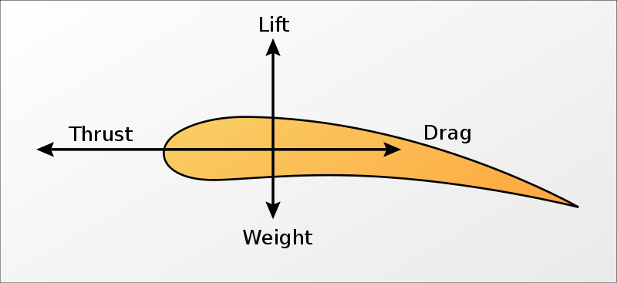

**Link to video explaining the lift of airplane wings**: http://www.youtube.com/watch?v=bv3m57u6ViE&desktop_uri=%2Fwatch%3Fv%3Dbv3m57u6ViE

* 1. Birds and airplanes both use their wings to fly. Compare and contrast birds and airplanes. How are they different from each other? How are they the same?
  2. Engineers often design human machines using animal models. Besides birds and airplanes, can you think of any other examples?

1. Discuss the analysis discussion questions as a class.

**Closure:** If flying animals (such as birds) did not exist do you think that engineers would still have designed airplanes? Where might the idea have come from? How can our knowledge of the natural world lead to new technologies and ideas? Suppose you wanted to design a remote controlled spying device. Which types of animals might you study to help you design your device?

**Assessment:** Science notebooks responses, reading notes, class discussions and questions, analysis discussion question answers from the bird and airplane wing reading





**Bernoulli’s Principle and the Coanda Effect:**

**Demonstrations and a Simple Experiment**

**Demonstration #1**

**Bernoulli’s Principle:** First, place a ping pong ball under an inverted funnel. Tell the students that you will blow into the small tube at the end of the funnel and ask them to predict what happens. Then, complete the demonstration and watch the ping pong ball rise. Discuss the results with the class and ask for explanations. Additionally, you can hold a ping pong ball inside an inverted funnel. Blow through the funnel and let go of the ball. The ball should stay in the funnel until you stop blowing. The explanation is the same.

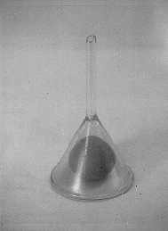

*Teacher Explanation*: Faster flowing air (blowing) decreases the air pressure on the top of the ball so the ball rises. The pressure on the bottom of the ball is the same. This is one way that airplane and bird wings get lift (faster flowing air over the top of the wing).

**Simple Experiment #1**

**Bernoulli’s Principle:** Pass out a strip of paper (approximately 1 inch by 8 inches long) to each student. Tell the students that they will place the end of the paper just below their bottom lip and then blow a steady stream of air across the paper. Ask the students to make predictions about what will happen and then complete the experiment. Discuss with the class. The explanation is the same as above.

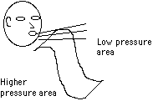 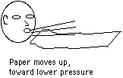

**Demonstration #2**

**Coanda effect:** Arrange the class around the sink in the classroom and get the metal spoon out. Ask students which direction the water will go after it flows over the curved back of the spoon. Do the demonstration and lead a classing discussion relating this to the Coanda effect.

[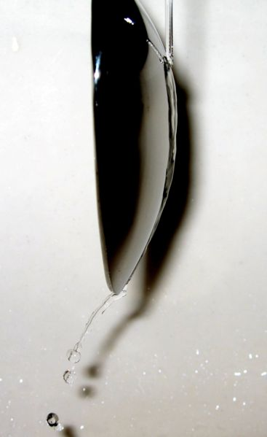](http://upload.wikimedia.org/wikipedia/en/7/75/Coanda_Spoon.jpg)

*Teacher Explanation*: In this case, liquids and gases both have this property. Basically, a stream of liquid or gas will stay attached to a curved surface, rather than continue in a straight line. Wings direct air down. Then, this air meets with pressure from the air below it, creating lift.