**Water Cycle**

**Lesson #5:** **Creating a Water Cycle Story**

**(Supplementary Lesson to be taught by the Classroom Teacher)**

**Time Frame:** 45-60 minutes

**Learning Standards:**

*Science*

Earth and Space Science: The Water Cycle

1. Describe how water on earth cycles in different forms and in different locations, including underground and in the atmosphere.

Physical Science: States of Matter

1. Describe how water can be changed from one state to another by adding or taking away heat.

**Student will be able to:**

1. Create, describe, and diagram a story about a droplet of water going through the water cycle using appropriate vocabulary.

**Resources and Materials:**

|  |  |
| --- | --- |
| **Item** | **Amount** |
| Science notebooks |  |
| Water cycle diagram | 1 (in bin from Lesson #1) |
| Water cycle story student copies | 80 (in bin) |
| Colored pencils or markers (not provided) | (in classroom) |

**Vocabulary:** evaporation, condensation, precipitation, run-off, infiltration (percolation), ground water

**Focus Activity:** Refer to the color copies of the water cycle diagram from Lesson 1 of the Water Cycle unit. Review the processes that occur in the water cycle with the class. Ask questions to check for understanding and answer questions as necessary. Refer to the terrariums as mini-models of the water cycle.

**Introduction:** Explain that students will imagine that they are a droplet of water in the water cycle. They will then write a story about their journey from one point in the water cycle through the entire cycle, using appropriate vocabulary, and color in a diagram demonstrating the path that the water droplet takes.

**Activity:**

1. Write the vocabulary listed above on the board and review the terms with the class. Provide definitions as necessary.
2. Give each student a water cycle story handout and review the directions for writing the story and completing the diagram.
3. Assist students when necessary as they choose a starting point for their water droplet and then describe at least three processes that take the water droplet to 3 other locations in the water cycle. Students will diagram, label, and number the path their water droplet takes using the picture of the water cycle on their handout.
4. Students who finish may make add more steps to the path of their water droplet or turn their story into a cartoon with specific diagrams for each step.

**Closure:** Ask students to show their water cycle stories with a partner and discuss the path of their water droplets. Discuss the following questions as a class: Does it matter that students chose to start in different places? Why or why not? Did most water droplets undergo similar processes? Why or why not? How is all the water on earth and in the atmosphere connected?

**Assessment:** Participation in class discussions and activities, completion of the water cycle story

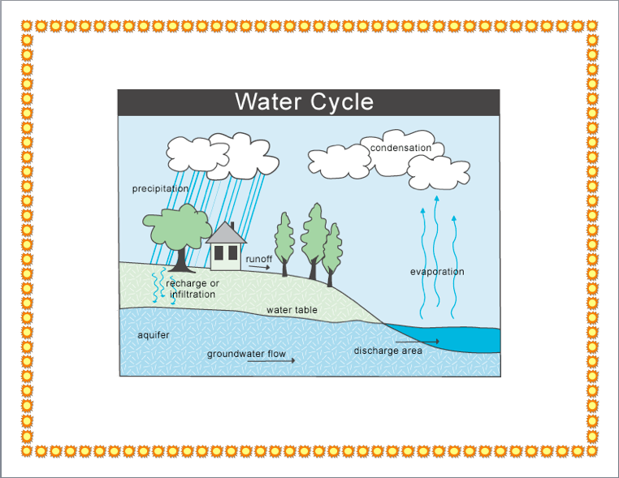

**The Water Cycle Story**



**Vocabulary:** water, solid, liquid, gas, evaporate (evaporation), condense (condensation), precipitation, collection, infiltration, ground water, run-off

Write a story about one droplet of water in the water cycle. Use the vocabulary words above. Your water droplet must go through at least 4 different locations. Then color, number, label, and add arrows to the diagram showing the path of your water droplet.

**Start (#1):** __________________________

Process: ___________________________________________

_____________________________________________________________________________________________________________________________________________________________________

**Location #2:** ________________________

Process: ___________________________________________

_____________________________________________________________________________________________________________________________________________________________________

**Location #3:** ________________________

Process: ___________________________________________

_____________________________________________________________________________________________________________________________________________________________________

**End (#4):** ___________________________