Adaptation and Behavior

Lesson #5: Bird Beak Adaptation

Time Frame: 120 minutes (split into two lessons)

Learning Standards:
Science
Life Science: Plant (and Animal) Structures and Functions
- Give examples of how inherited characteristics may change over time as adaptations to changes in the environment that enable organisms to survive, e.g., shape of beak or feet, placement of eyes on head, length of neck, shape of teeth, color.
Skills of Inquiry
- Ask questions and make predictions that can be tested.
- Select and use appropriate tools and technology in order to extend observations.
- Keep accurate records while conducting simple investigations or experiments.
- Conduct multiple trials to test a prediction. Compare the result of an investigation or experiment with the prediction.
- Recognize simple patterns in data and use data to create a reasonable explanation for the results of an investigation of experiment.
- Record data and communicate findings to others using graphs, charts, maps, models, and oral and written reports.
Math
Data Analysis, Statistics, and Probability
- 5.D.2 Construct and interpret line plots, line graphs, and bar graphs. Interpret and label circle graphs.
Number Sense and Operations
- 6.N.9 Select and use appropriate operations to solve problems involving addition, subtraction, multiplication, division, and positive integer exponents with whole numbers, and with positive fractions, mixed numbers, decimals, and percents.
English / Language Arts
Oral Presentation
- 3.8 Give oral presentations for various purposes, showing appropriate changes in delivery and using language for dramatic effect.

Student will be able to:
- Predict what type of food different birds eat based on the shape of their beak.
- Experiment with model beaks and food sources and collect, record, graph, and analyze data to determine which type of beak is best suited for which type of food.
- Explain how birds are adapted to eat a certain type of food and describe what would happen to a bird population if its environment changed.
- Present the results of the bird beak experiment to the class.

Resources and Materials for both parts:

Item | Amount
Science notebooks
Bird beak overhead (pictures of bird beaks) | (in binder)
Bird beak adaptations student instructions, data and analysis, and graph | (in bin)
Bird beak challenge instructions | (in binder)
Stopwatches or clock | 6 (in bin or from classroom)
Demonstration materials  Graduated cylinder  Box of food coloring  Extras for the different challenges | (in bin)  1  1  (use materials from the challenges for the other demonstrations)  Various amounts
Challenge #1:  Challenge #1 instructions  Graduated cylinder  Cup with a marked line  Shoestring  Dropper  Sponge strip | (in bin)  10  1  1  1  1  1
Challenge #2:  Challenge #2 instructions  Gummy worms  Cup  Straw  Chopsticks  Wrench/Pliers  Potting soil  Deep metal pan | (in bin)  10  1 bag  1  2  1  1  1 bag  1
Challenge #3:  Challenge #3 instructions  Sunflower seeds  Cup  Pliers  Chopsticks  Tweezers | (in bin)  10  1 bag  1  1  1 pair  1
Challenge #4:  Challenge #4 instructions  Styrofoam pieces  Cup  Chopsticks  Tweezers  Slotted spoon  Shallow pan | (in bin)  10  1 bag  1  1 pair  1  1  1
Challenge #5:  Challenge #5 instructions  Rice  Circular piece of Styrofoam  Dropper  Tongs  Tweezers | (in bin)  10  1 bag  1  1  1  1
Challenge #6:  Challenge #6 instructions  Marshmallows  String  Chopsticks  Tongs  Skewers | (in bin)  10  1 bag  1 roll  1 pair  1  1
Build-a-bird activity cutouts | (in bin)

General Teacher Background Information
Animal adaptations are any body shape, process, or behavior that allows an organism to survive in its environment. Populations of animals change over time in response to their environment. Why do birds have different shaped beaks? Birds have many different kinds of beaks, depending on what they eat and where their food source is. For instance, birds may find their food in water, mud, flowers, seeds, or in wood. The different shapes of beaks allow easier access to these various food supplies. If an environment altered, organisms within the area might not survive. Adaptation to a particular environment occurs over time as organisms best suited to the environment survive and reproduce, and pass their inherited traits to the next generation.

Lesson 5 Part I: Beaks and Food

Focus Activity: Use an overhead (or PowerPoint) with pictures of birds and their beaks (the beaks of these birds reflect the supplies you are using). Have students open their science notebooks and predict what each bird eats with its beak and write any ideas they have about how it might use its beak to eat. Tell students to sketch the beak next to their predictions.

Introduction: Pass out the Bird Adaptation handouts to each student. Review the definition of adaptation from the last science lesson. Discuss the following questions as a class. What does adaptation mean? What are some examples of adaptations? How might living things become adapted to their environment? (Remember, adaptations must be inherited.)
Then, relate adaptations to birds. Ask the students to share with the class what they know about birds. What makes a bird a bird? What do birds need to survive? What kinds of food do they think birds eat? (Insects, seeds, berries, and meat are among the most common.) Where do birds live?

Activity:
- Arrange the following materials in front of the class (set this up before class and use these same materials for the challenge stations):
1. A tall, thin vase filled with colored water (replace the colored water the clear water for the challenge station)
2. A dish of potting soil with gummy worms buried throughout
3. Sunflower seeds spread throughout a pan
4. A dish of water with styrofoam cubes floating in shallow water
5. Rice grains tucked into Styrofoam
6. Marshmallows hanging on strings
Tell students that each of these items represents a type of food eaten by various birds. Ask students if they can hypothesize what a bird would have to do in order to reach the food supply. Does the shape of a bird's beak limit what they can eat?

Teacher Information: The specific birds that eat each type of food should be discussed at the end of class after the group presentations.
1. Nectar (colored water) needs to be sucked out Hummingbird
2. Worms (gummy worms) need to be dug and pulled out Robin
3. Seeds (sunflower seeds) need to be cracked open Sparrows, Finches
4. Fish (styrofoam pieces) need to be scooped out of the water Heron
5. Small insects (rice) need to be pried out of small crevices Woodpeckers
6. Meat (marshmallows) will need to be pulled off of bones Owls, Hawks

- Divide Students into groups of three or more (there will be six different group challenges, but you may want to have an extra station open for groups that work faster, so divide students accordingly).
- Make sure the challenge stations and equipment are set up around the room. (Each station will have the challenge instructions, a food source, and a set of three different utensils, which they are to use as sample "beaks.")
- After reading their card, ask students to write their challenge number and which "beak" they predict will work best for "eating" their specific "food" in their science notebooks.
- Each group will time in seconds how long it takes to get a certain amount of "food" with each utensil. (See challenge cards). Students may work in groups to complete one, some, or all of the challenges depending on how many days spent on this activity.
Assign Roles: This activity will go more smoothly if each student has a different role for each trial. If the students are in groups of three, each one can perform a different task for each of the three trials. It may be helpful to write the responsibilities for each role on the board so that students may refer to them throughout the activity.
Materials Manager and Timer: set up the food source for the next beak, and use the stopwatch or clock to time the trials
Reader and Recorder: Read the directions and record the data in the chart provided
Experimenter: Conduct one trial for the bird beak experiment - use each of the three beaks to get the specified amount of food
- When the challenge card activities are done ask each group to calculate the average time for each beak to eat their food source and make a bar graph to represent their data.
Closure: Discuss the following ideas and questions as a class or in their groups. In your challenge, some tools were better at getting food than others. How are the trial tools you used relate to the different shapes of bird beaks? What did your challenge show you about bird beaks?

Lesson 5 Part II: Beaks and Food

Focus Activity: Ask students to get back into last week’s groups. Ask the groups to answer the analysis questions and assess their initial predictions in their lab notebooks.

Direct each group to make a brief presentation to the class about one of their challenges (try to have each group present a different challenge). Groups should describe their food model beaks and tell which beak worked the best. Then, they should explain which shape of beak and bird from the overhead they think would best suit their food source. Ask the class if they can think of any other adaptations that might help each bird better survive in its habitat.

Class Presentation:
- As a group, describe your food source and which type of beak was fastest at eating this food (show the bar graph).
- Then, explain which shape of beak and bird from the overhead would be best at eating this type of food. Use the evidence from your challenge to back up your explanations.

Bird Beak Analysis:
Complete the following questions in your science notebooks.
- Write an explanation next to your prediction. Was your prediction correct or incorrect? How did your ideas change after doing the experiment?
- Describe what might happen to a bird population if its natural environment experienced a natural disaster where all plants and animals were wiped out. For example, what would happen to a woodpecker if all of the trees burned down? What would happen to a heron if a farmer used a dangerous pesticide on his crops?

Activity:
- In their groups, have students create a bird that feeds on a particular food source. Be sure to include adaptations in addition to their beaks, such as long legs for a wading bird like the heron. Draw a picture (or use the bird cutouts) and write a description of what adaptations this bird has that allow it to successfully feed on its food source.
- Have the groups present their birds. Describe the bird and why it has certain adaptations.

Closure: Discuss the following ideas and questions as a class. How is a heron better adapted to catch a fish than a woodpecker? How is a duck better adapted to an aquatic environment than an owl? How are different types of birds adapted to their environments and food source? What would happen to a bird population if its food source disappeared? What would happen to the hummingbirds that summer in Williamstown if all the flowers died?

Assessment: Science notebooks responses, participation in discussion and lab activities, bird beak graph and analysis questions, bird beak presentations

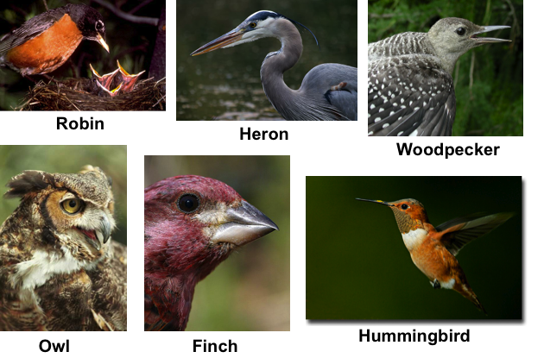

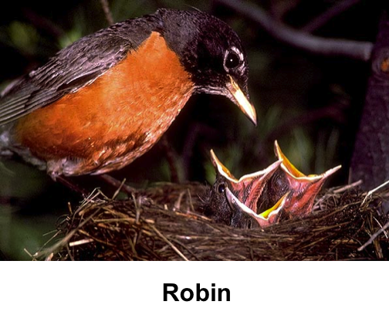

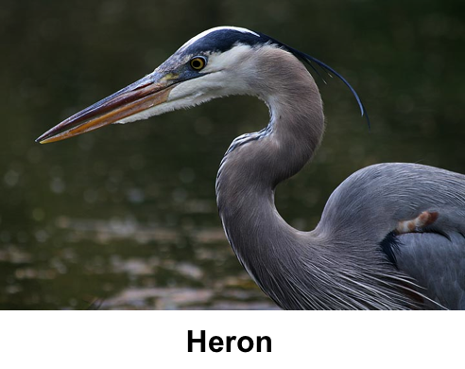

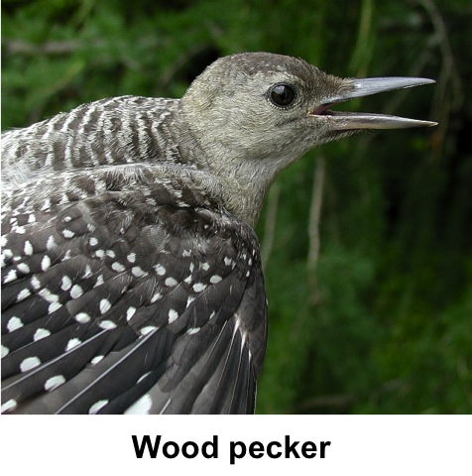

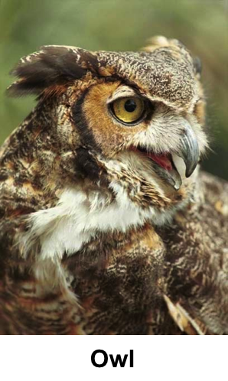

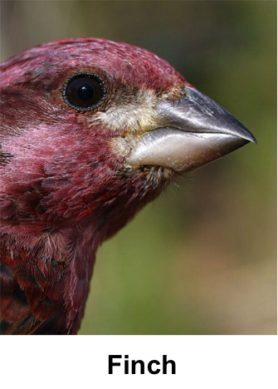

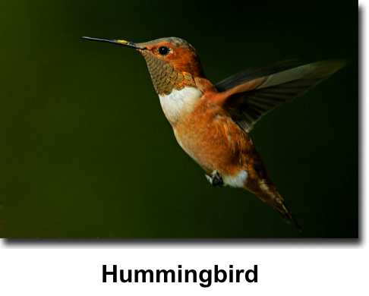

Challenge #1

Food source: graduated cylinder with water
Sample beaks: shoestring, dropper, sponge strip

Procedure:
- Find out how many seconds it takes each beak to fill the cup with water from the graduated cylinder.
- Complete 3 trials with each beak.
- Record your times in the data table.
- Calculate the average time for each beak.
- Construct a bar graph of the averages.

Challenge #2

Food source: gummy worms
Sample beaks: straw, chopsticks, wrench/pliers

Procedure:
- Find out how many seconds it takes to remove three gummy worms from the dirt using each beak.
- Complete 3 trials with each beak, burying the worms after each trial.
- Record your times in the data table.
- Calculate the average time for each beak.
- Construct a bar graph of the averages.

Challenge #3

Food source: sunflower seeds
Sample beaks: pliers, chopsticks, tweezers

Procedure:
- Find out how many seconds it takes each beak to crack three sunflower seeds and remove the seeds inside.
- Complete 3 trials with each beak.
- Record your times in the data table.
- Calculate the average time for each beak.
- Construct a bar graph of the averages.

Challenge #4

Food source: Floating Styrofoam squares
Sample beaks: chopsticks, tweezers, slotted spoon

Procedure:
- Find out how many seconds it takes each beak to remove all of the Styrofoam squares from the water.
- Complete 3 trials with each beak, returning the squares after each trial.
- Record your times in the data table.
- Calculate the average time for each beak.
- Construct a bar graph of the averages.

Challenge #5

Food source: rice (in Styrofoam)
Sample beaks: dropper, plastic tongs, tweezers

Procedure:
- Find out how many seconds it takes for each beak to remove twenty grains of rice from the bark of a tree (Styrofoam).
- Complete 3 trials with each beak, returning the rice to the bark each time.
- Record your times in the data table.
- Calculate the average time for each beak.
- Construct a bar graph of the averages.

Challenge #6

Food source: hanging marshmallows
Sample beaks: chopsticks, metal tongs, skewer

Procedure:
- Find out how many seconds it takes for each beak to remove five marshmallows from the strings.
- Complete 3 trials with each beak.
- Record your times in the data table.
- Calculate the average time for each beak.
- Construct a bar graph of the averages.

Bird Adaptations: Beaks and Food Part I

Predictions: Observe and interpret the 6 pictures provided of the different types of birds. Open your science notebooks and predict what each bird eats with its beak and write any ideas you have about how it might use its beak to eat. Sketch the beak next too each prediction.

Procedure:
    - After you are in a group, go to a challenge station. Each station will have a different food source and a set of three different utensils, which you are to use as sample beaks.
    - Read the challenge card.
    - Write your challenge number and which model beak you predict will work best for eating the food in your science notebooks.
    - Each person in the group will have a different role for each trial.
Materials Manager and Timer: Set up the food source for the next beak and use a stopwatch or clock to time the trials
Reader and Recorder: Read the directions and record the data in the chart provided
Experimenter: Conduct one trial with each bird beak
    - Each group will time in seconds how long it takes to get a certain amount of food with each model beak. (See challenge card.)

Bird Adaptations: Beaks and Food Part II

Class Presentation:
- As a group, describe your food source and which type of beak was fastest at eating this food (show the bar graph).
- Then, explain which shape of beak and bird from the overhead would be best at eating this type of food. Use the evidence from your challenge to back up your explanations.

Bird Beak Analysis:
Complete the following questions in your science notebooks.
- Write an explanation next to your prediction. Was your prediction correct or incorrect? How did your ideas change after doing the experiment?
- Describe what might happen to a bird population if its natural environment experienced a natural disaster where all plants and animals were wiped out. For example, what would happen to a woodpecker if all of the trees burned down? What would happen to a heron if a farmer used a dangerous pesticide on his crops?

Extension Activity:
On another sheet of paper, create a bird that feeds on a particular food source. Be sure to include adaptations in addition to their beaks, such as long legs for a wading bird like the heron. Draw a picture (or use the bird cutouts) and write a description of what adaptations this bird has that allow it to successfully feed on its food source.
Bird Adaptations: Beaks and Food

Student Data and Analysis Sheet

Group Member Names: _________________________________________________

Challenge #____ Food source: _______________

Bird Beak Data Table
Type of Beak Tested: | Trial #1  (in seconds) | Trial #2  ( in seconds) | Trial #3  (in seconds) | Average Time  (in seconds)

To calculate the average time:

Trial #1 + Trial #2 + Trial #3 = Average time
3 (number of trials)

Add the total number of seconds from each of the 3 trials.
Then, divide that number by 3.
This is the average time it takes the type of beak tested to get the food.

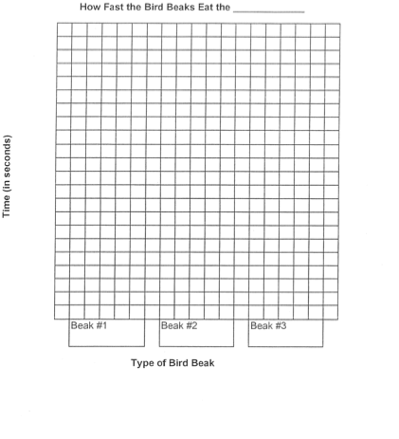

Build A Bird

Body
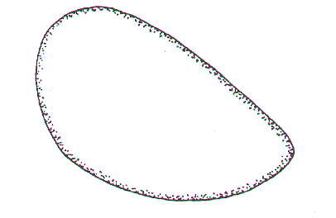

Heads
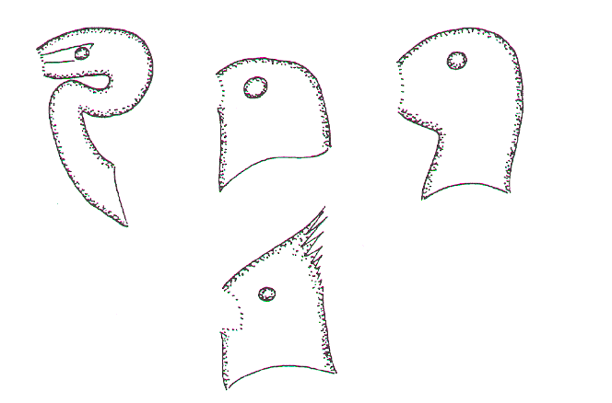

Beaks
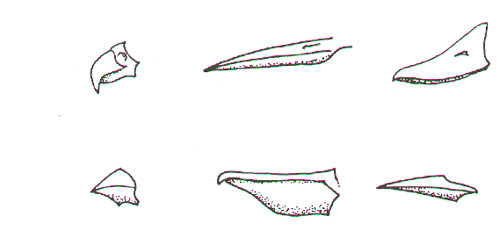

Legs and Feet
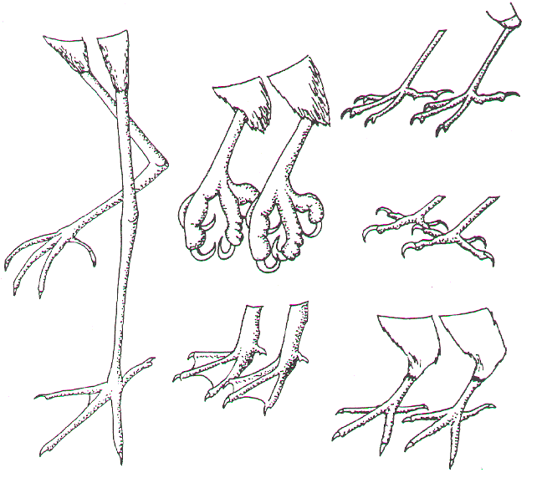
Tails
